CS 255 System Design Document Template

Nicholas DaRosa
3/1/2026
Southern New Hampshire

UML Diagrams

UML Use Case Diagram
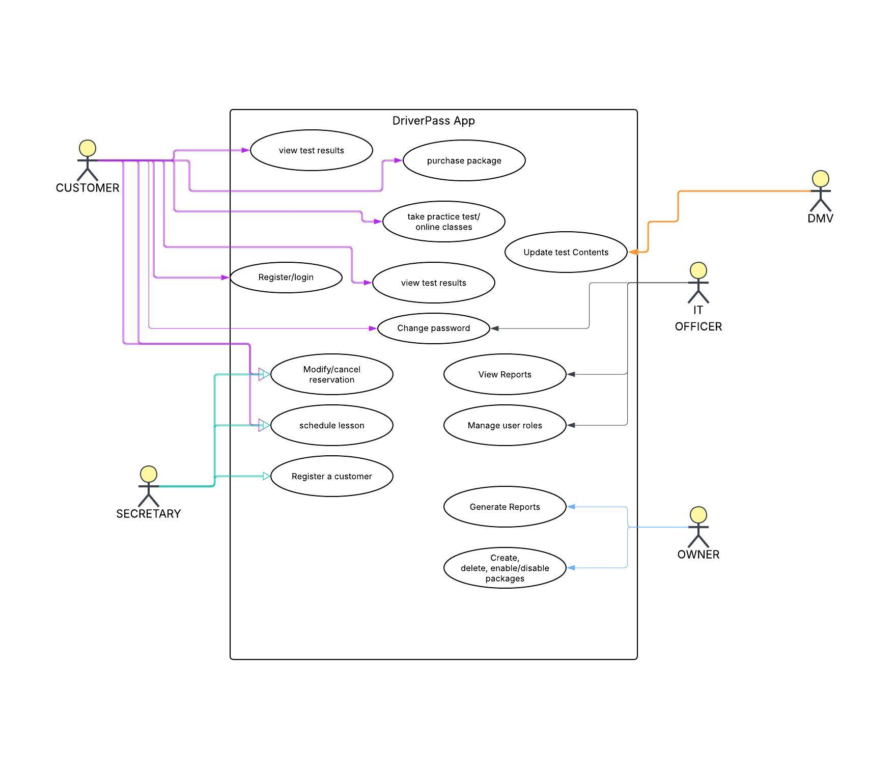

UML Activity Diagrams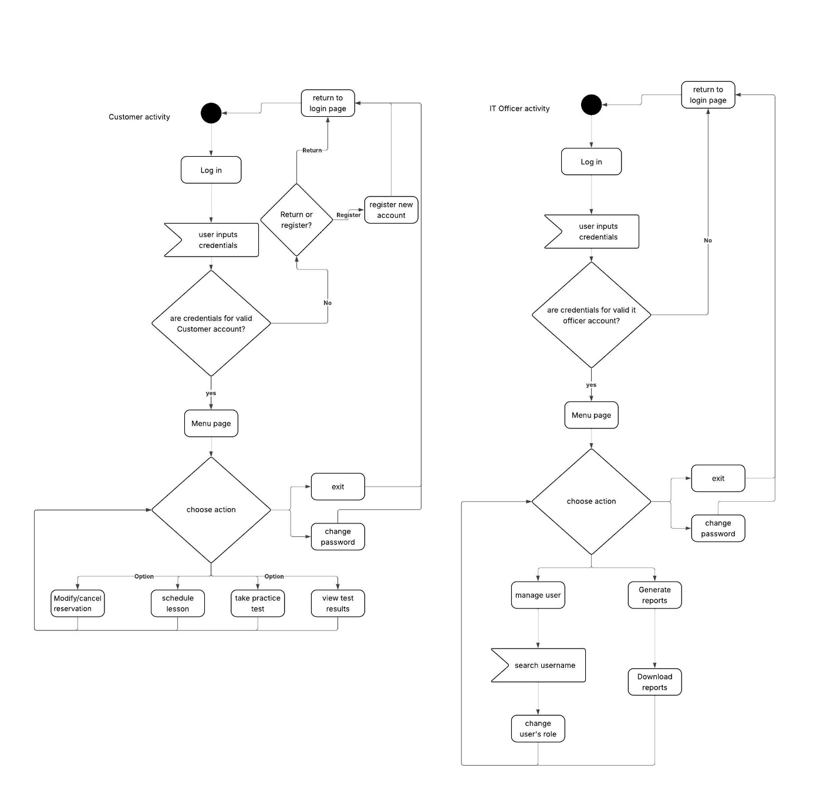

UML Sequence Diagram
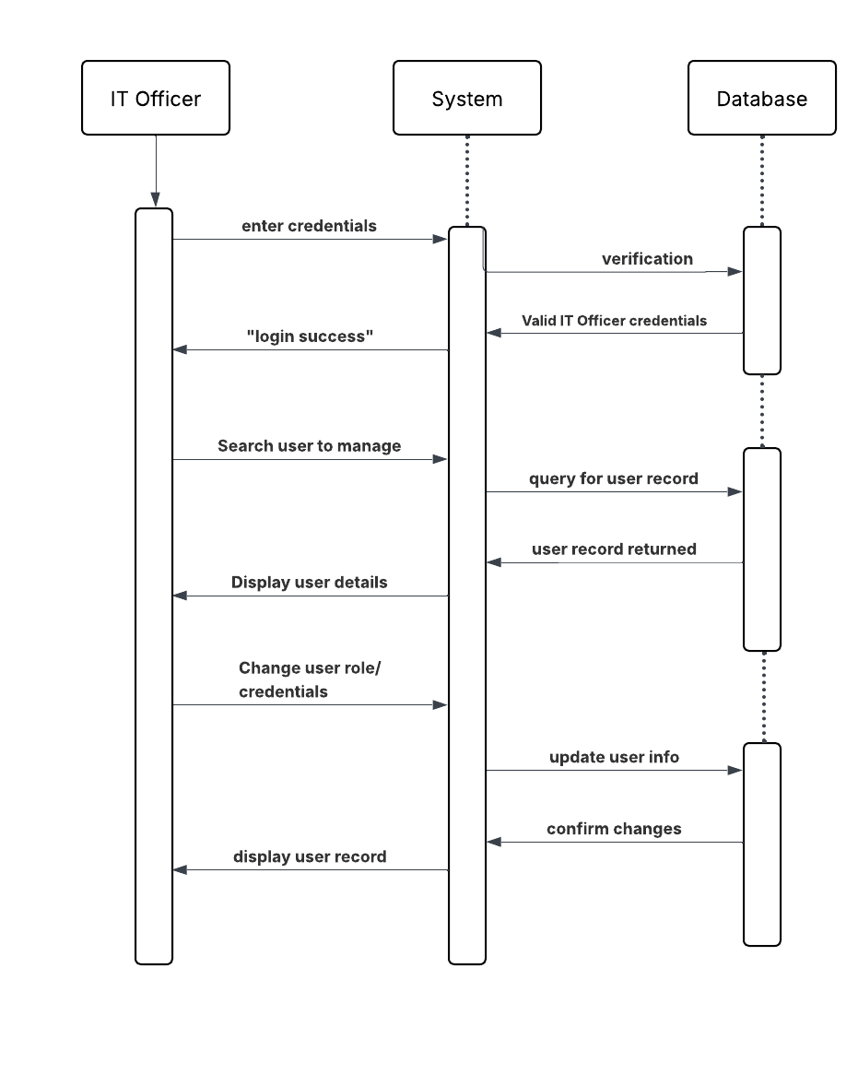

UML Class Diagram
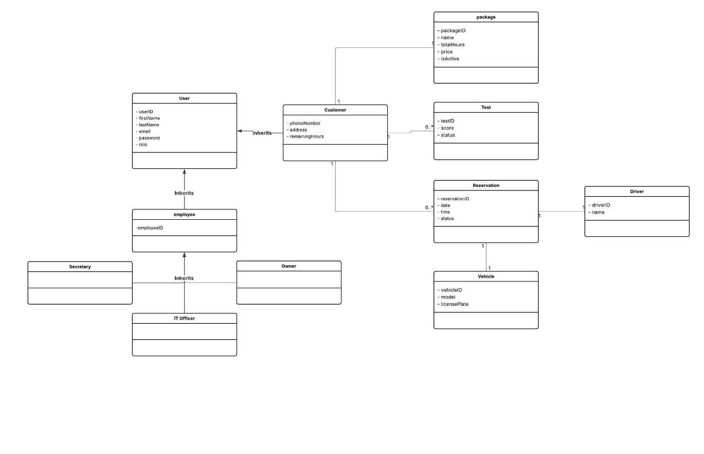

Technical Requirements

Hardware Requirements
- Cloud-based servers to host the web application and database
- data storage for customer and reservation information
- User devices with internet access
- Reliable internet for online access
Software Requirements
- Database to store users, packages, reservations, and test data
- payment processing system
- User authentication
- User role differentiation (Customer, Secretary, IT Officer, Owner)
- Reporting tools to generate system and activity reports
Development Tools
- Web application development framework
- Database design and management tools
- Lucidchart for system design
- Testing tools to verify system functionality and security
Infrastructure Requirements
- Secure cloud hosting environment
- Data encryption to protect sensitive information
- Automatic data backup and recovery system
- Scalable system design for future installments/updates

